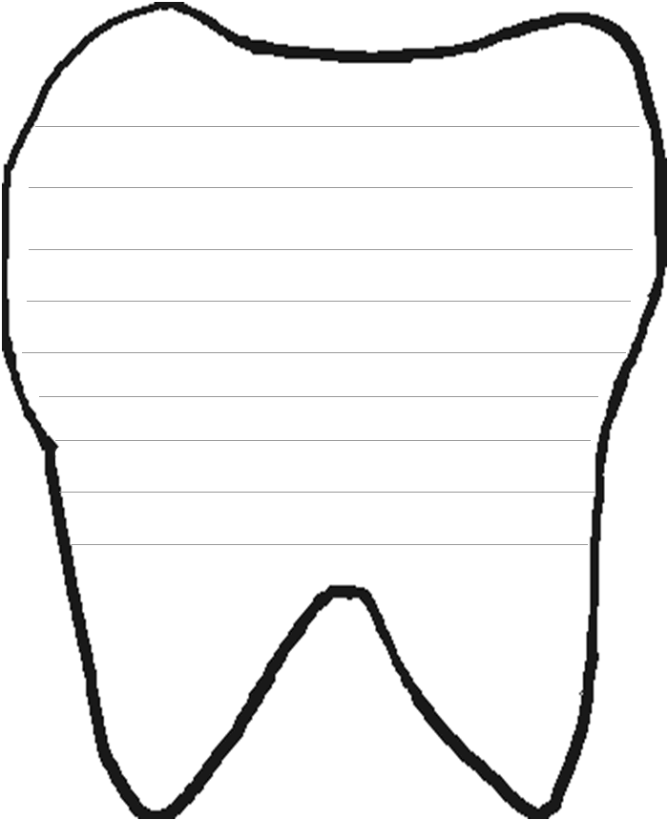
Name: ____________
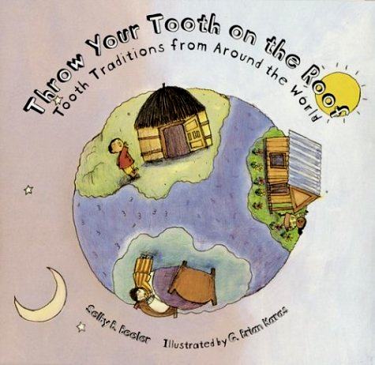
We learned about lost tooth traditions in the book: Throw Your Tooth on the Roof: Tooth Traditions from Around the World by Selby Beeler
I will use my imagination and write my own lost tooth tradition.

